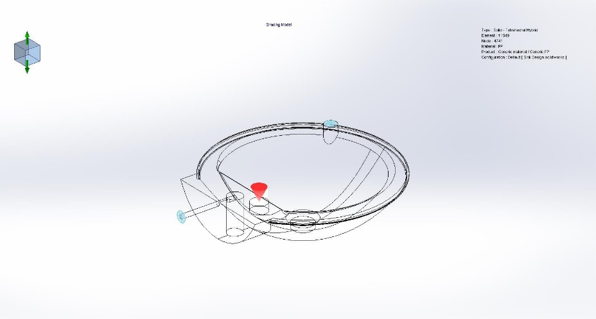
  INJECTION MOLDING FLOW ANALYSIS OF SINK MOLD
  Date:
  Department:
  Created by:
  Table of Contents
  Description 1
  Machine Information 2
  Study Characteristics 2
  Injection Unit Settings 3
  Polymer Properties 6
  Domains 7
  Boundary Conditions 8
  Global Parameters 10
  Mesh Details 11
  Fill Results 12
  Pack Results 31
  Material Parameter 44
  X-Y Plot 52
  Conclusion: 56

Description

Machine Information

Comments:

Number of Processors | 8
Maximum number of threads | 8
Number of available threads | 8
Software type | Windows 10
SOLIDWORKS Plastics version | SOLIDWORKS Plastics Premium 2025 SP1.0

Study Characteristics

Comments:

Part name | Sink Design solidworks
Configuration | Default
Study Name | FLOW ANALYSIS
Injection Process | Single Material
Number of Injection Units | 1
Analysis (Mesh) Procedure | Solid
Simulation Type | Fill + Pack

Injection Unit Settings

Unit 1

Material | Generic material / Generic PP
Filling Time | Automatic
Melt Temperature | 230 °C
Mold temperature | 50 °C
Injection Pressure Limit | 100 MPa
Fill/Pack Switch Point (% Filled Volume) | 100 %
Temperature Criteria for Short Shots | 135°C
Mold Temperature Profile | Off
Mold-Melt Heat Transfer Coefficient | Off
Pressure Holding Time | Automatic
Pure Cooling Time | 80 sec

Flow Rate Profile Setting:
Time control (Relative control)/Base on filling time
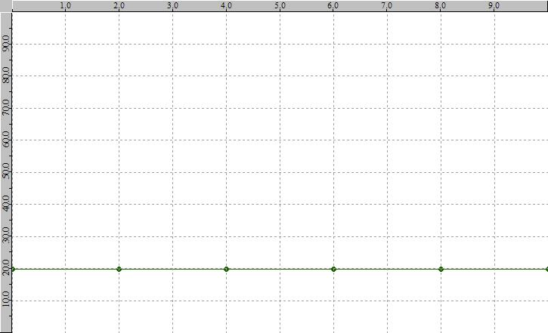

Pressure Profile Setting:
Relative to pressure at filling end (Relative control)
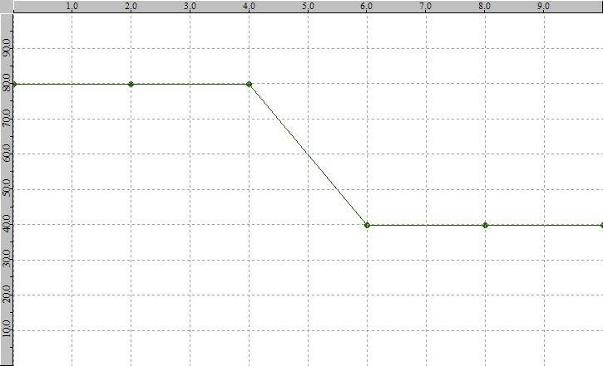

Polymer Properties

Generic material / Generic PP

Ejection Temperature | 95°C
Transition Temperature | 135°C
Young Modulus | E1: 1350 MPa, E2: 1350 MPa
Poisson's Ratio | v12: 0.4, v23: 0.4
Max. Shear Rate | 100000 1/s
Max. Shear Stress | 0.25 MPa
Fiber Percentage | Not Available

Domains
Name | Image
Combine2 (-Cavity-) | 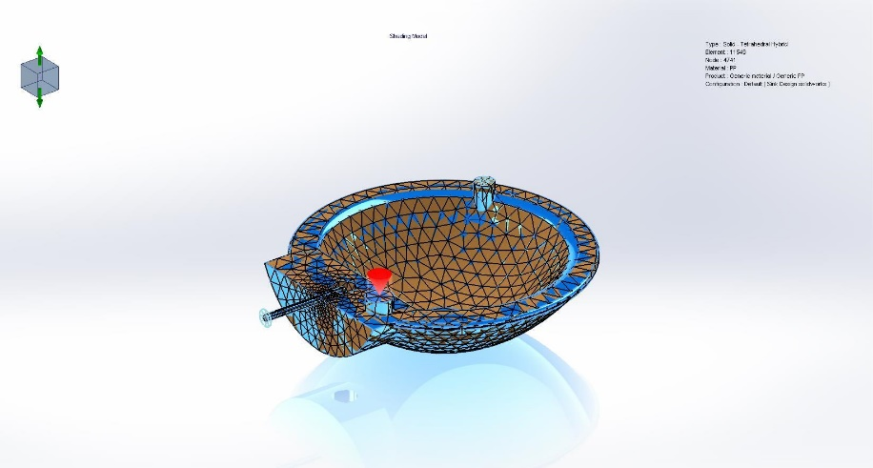

Boundary Conditions

Name | Boundary Condition Image | Details
Injection Location-1 | 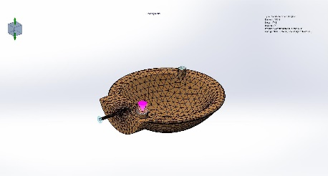
  Entity name:

Name | Boundary Condition Image | Details
Clamp Force-1 | 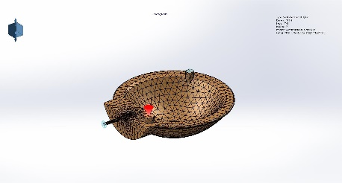
  Clamp Force Direction:
  Excluded Region:

Name | Boundary Condition Image | Details
Air Vents-1 | 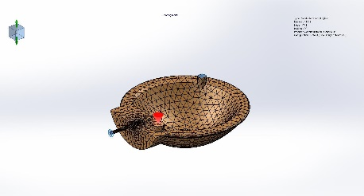
  Entity name:

Global Parameters

General

Clamp Force Limit | 100 Tonne
Ambient Temperature | 30 °C

Fill-Pack

Gravity Downward Direction for fill | -Y
Venting Analysis | Off
Solver Type | AMG
Volume of Fluid Algorithm | CICSAM

Warp

Gravity Downward Direction for warp | -Y
Solver Type | AMG

Cool

Mold Open Time | 5 sec
Specify control based on <Ejection Temperature /Cooling Time > | Ejection Temperature
Solver Type | AMG
Analysis Method | FEM-Linear

Mesh Details

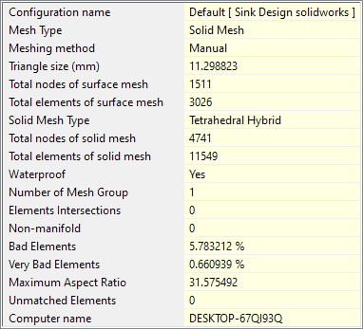

Fill Results
Comments:

Fill Summary
Clamp Force | 2.4426 Tonne
X-dir. Clamping Force | 1.1999 Tonne
Y-dir. Clamping Force | 2.4426 Tonne
Z-dir. Clamping Force | 1.2252 Tonne
Required injection pressure | 8.3592 Mpa
Max. real temperature | 230.1567 °C
Max. bulk temperature | 230.1565 °C
Max. shear stress | 0.2409 Mpa
Max. shear rate | 2883.3990 1/sec
CPU Time | 717.59 sec
Cycle Time | 115.16 sec
1. Filling Time | 10.16 sec
2. Total Time in Pack Stage | 100.00 sec
a). Pressure Holding Time | 20.27 sec
b). Pure Cooling Time | 79.73 sec
3. Mold Open Time | 5.00 sec

Name | Type | Min | Max
Fill Time | Fill Results | 0.010087 | 10.155290
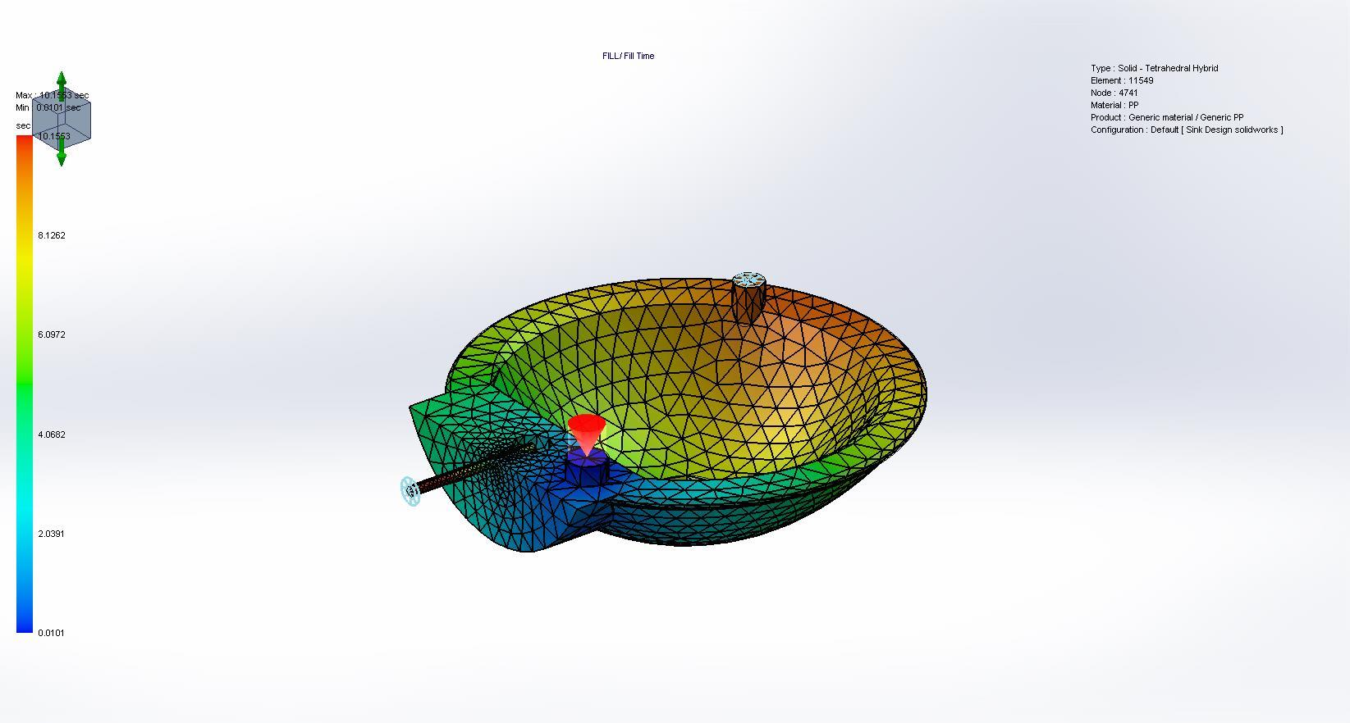

Name | Type | Min | Max
Pressure at End of Fill | Fill Results | 0.102751 | 8.359222
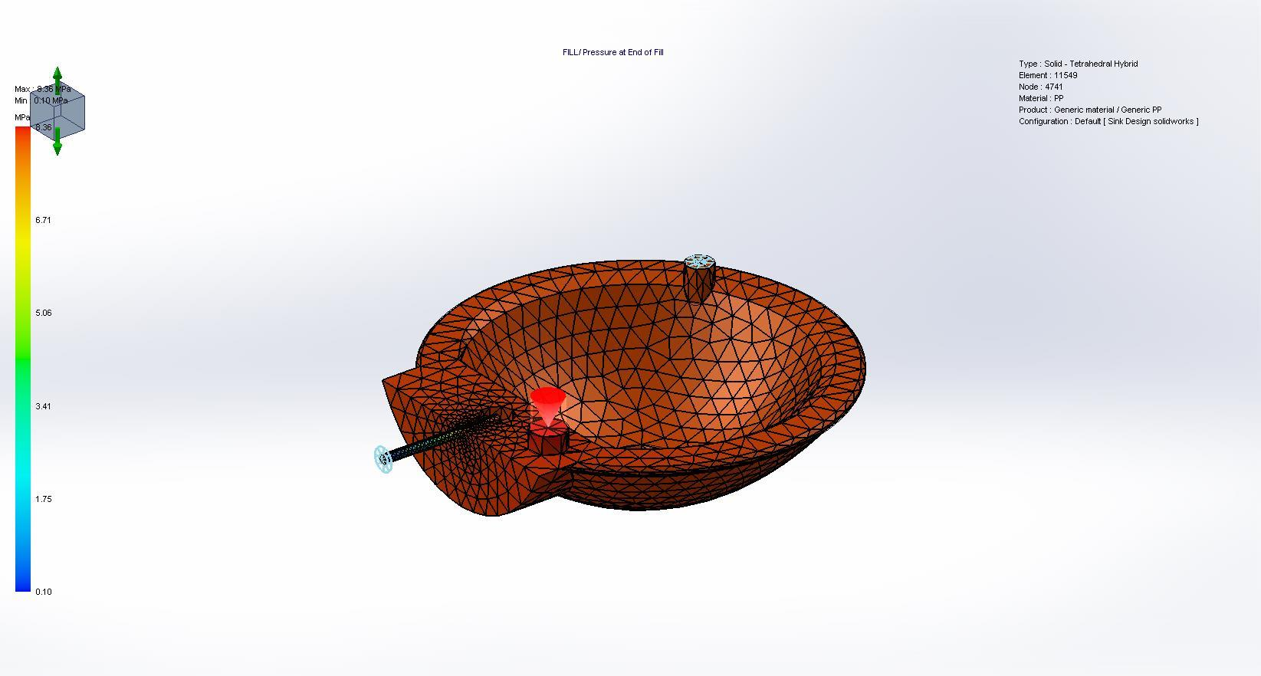

Name | Type | Min | Max
Temperature at End of Fill | Fill Results | 66.380928 | 230.006699
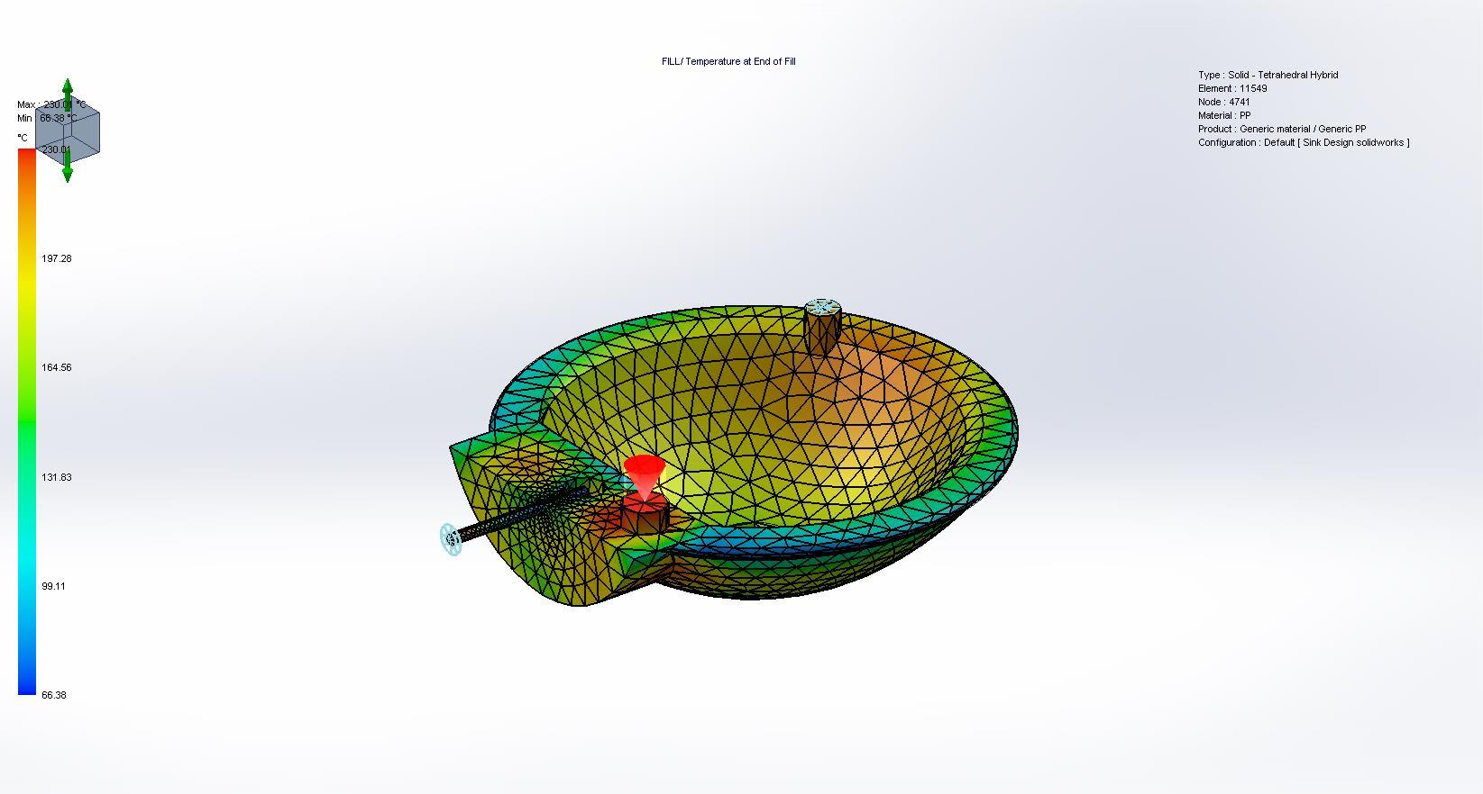

Name | Type | Min | Max
Bulk Temperature at End of Fill | Fill Results | 66.455360 | 230.006500
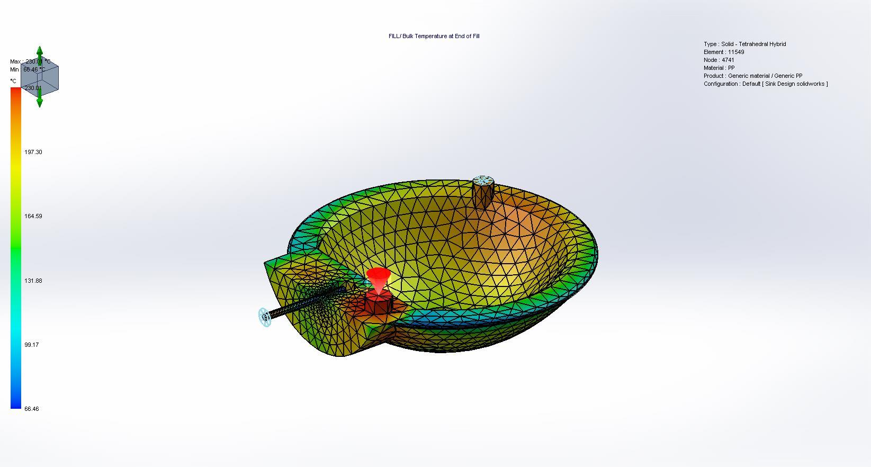

Name | Type | Min | Max
Flow Front Temperature | Fill Results | 178.105698 | 229.900696
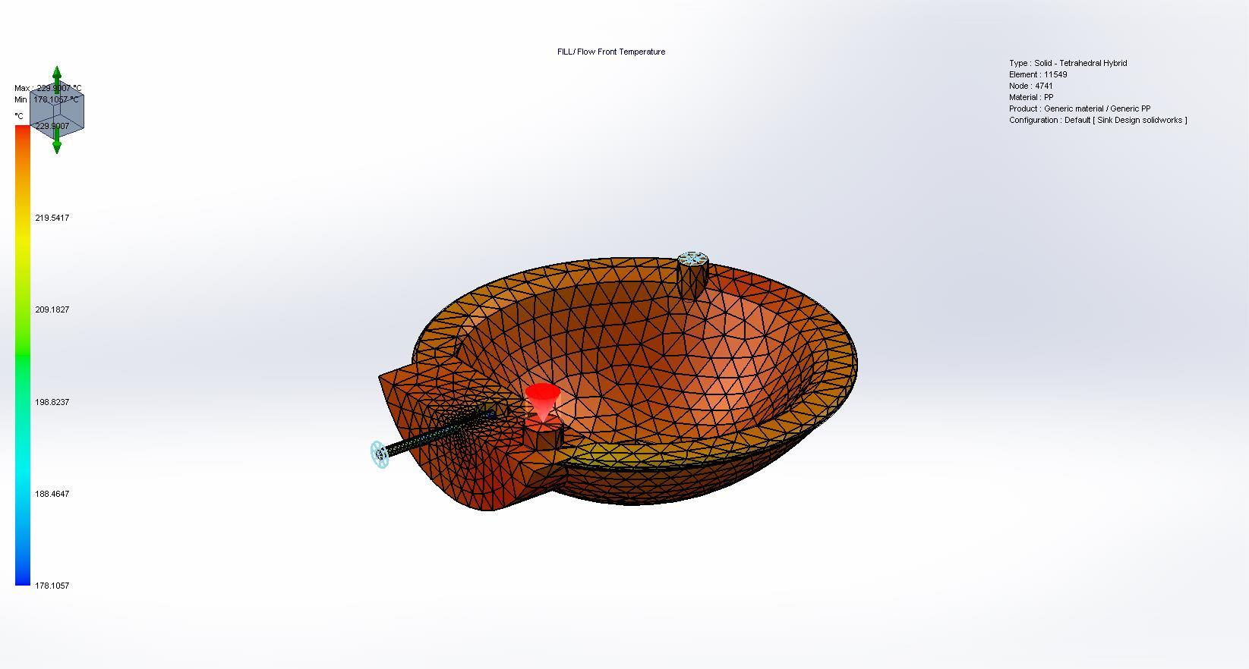

Name | Type | Min | Max
Temperature Growth at End of Fill | Fill Results | 0.000000 | 0.006468
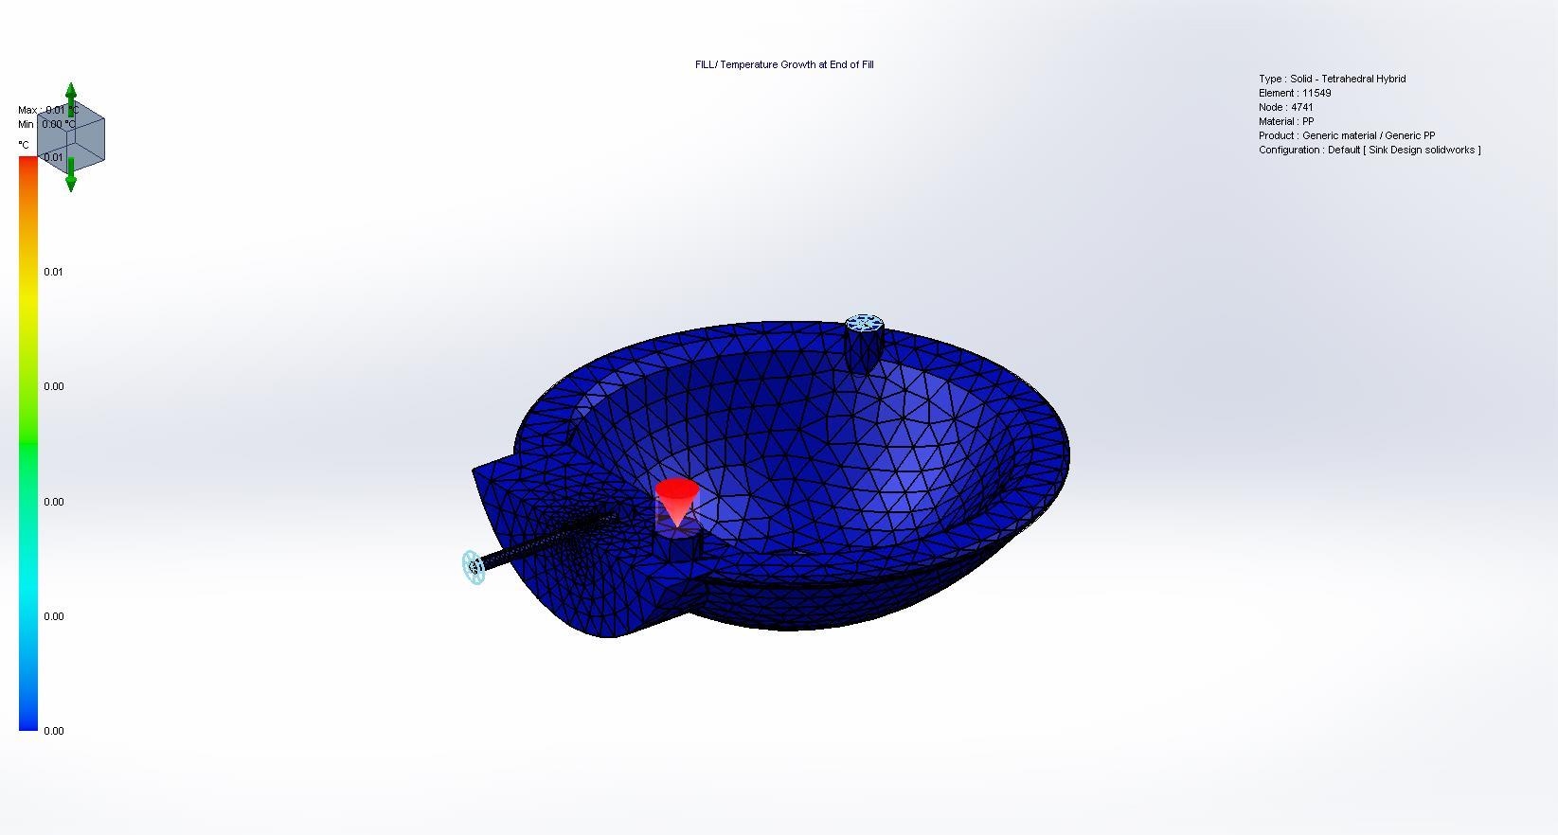

Name | Type | Min | Max
Shear Stress at End of Fill | Fill Results | 0.000080 | 0.240875
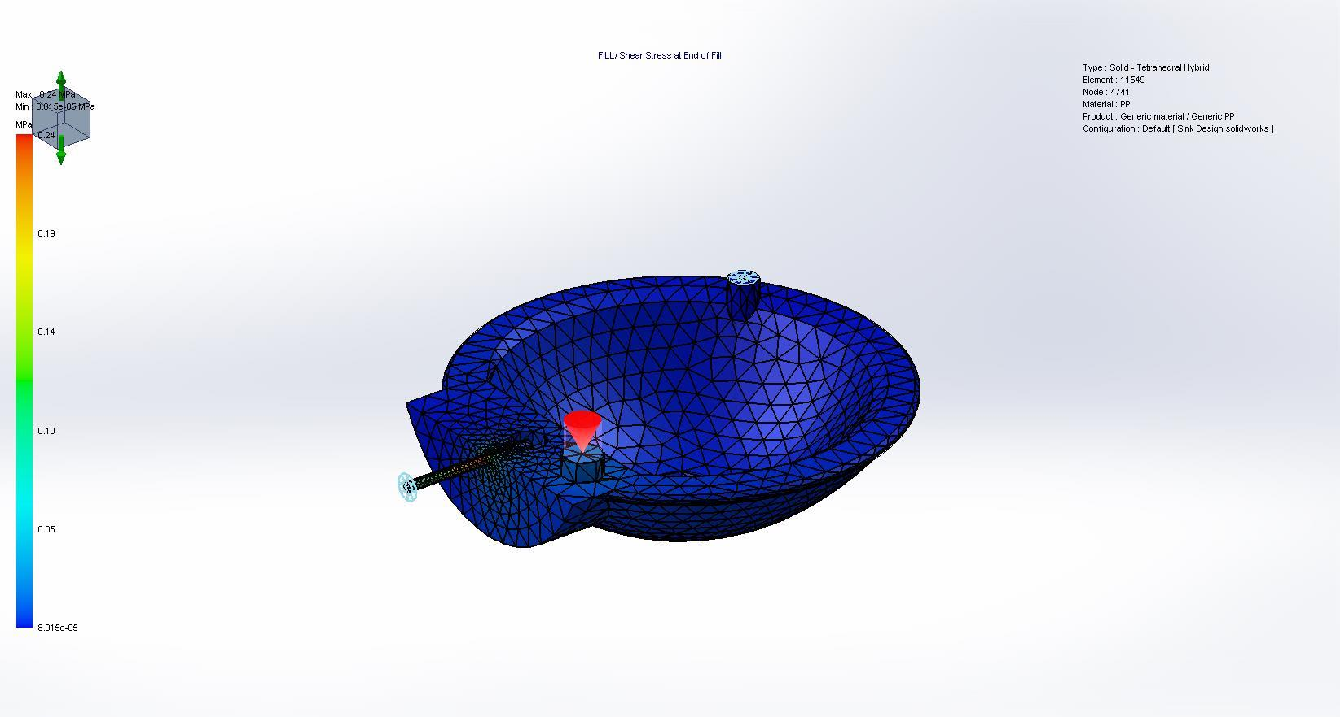

Name | Type | Min | Max
Shear Rate at End of Fill | Fill Results | 0.025106 | 2883.398926
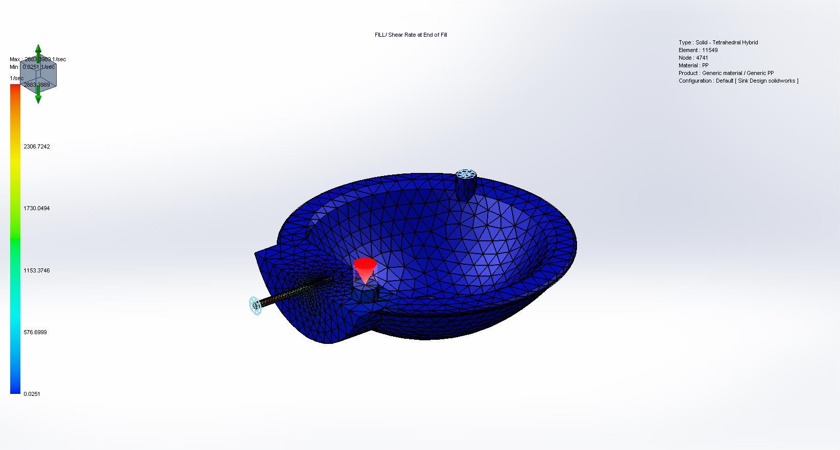

Name | Type | Min | Max
Volumetric Shrinkage at End of Fill | Fill Results | 4.067349 | 17.270281
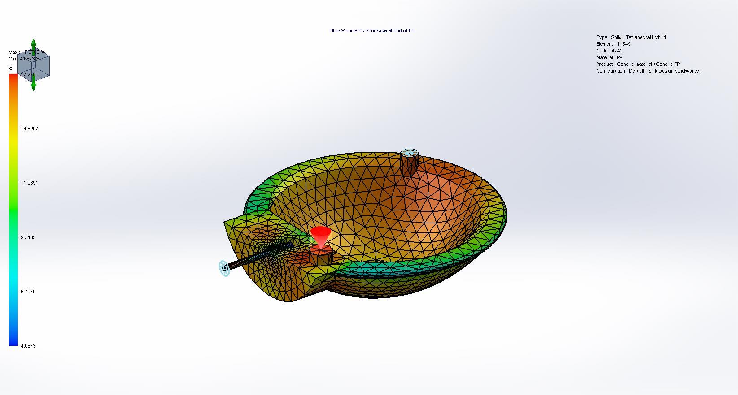

Name | Type | Min | Max
Freezing Time at End of Fill | Fill Results | 1.953608 | 10.154260
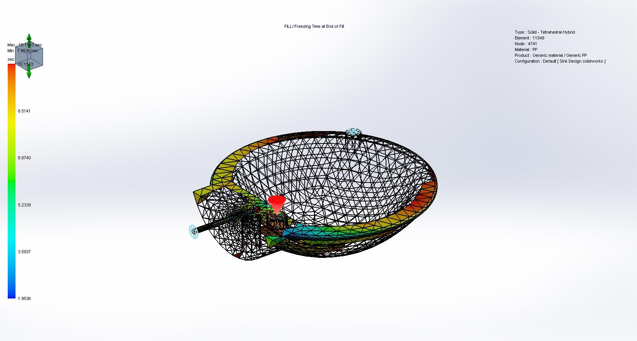

Name | Type | Min | Max
Cooling Time | Fill Results | 10.355290 | 816.155273
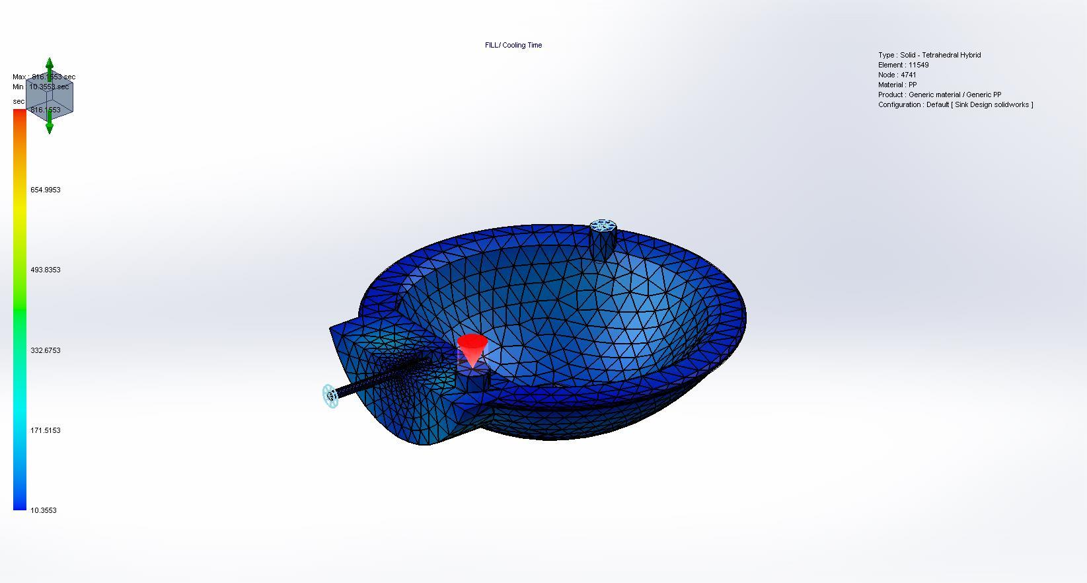

Name | Type | Min | Max
Temperature at End of Cooling | Fill Results | 49.999962 | 168.626495
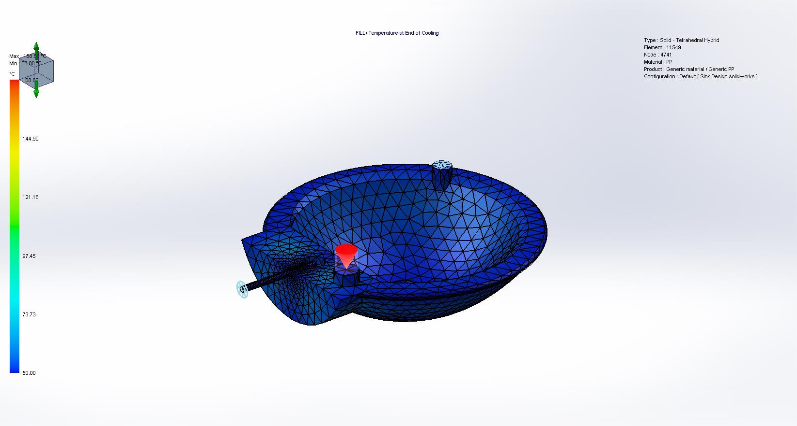

Name | Type | Min | Max
Frozen Area at End of Fill | Fill Results | 0.000000 | 1.000000
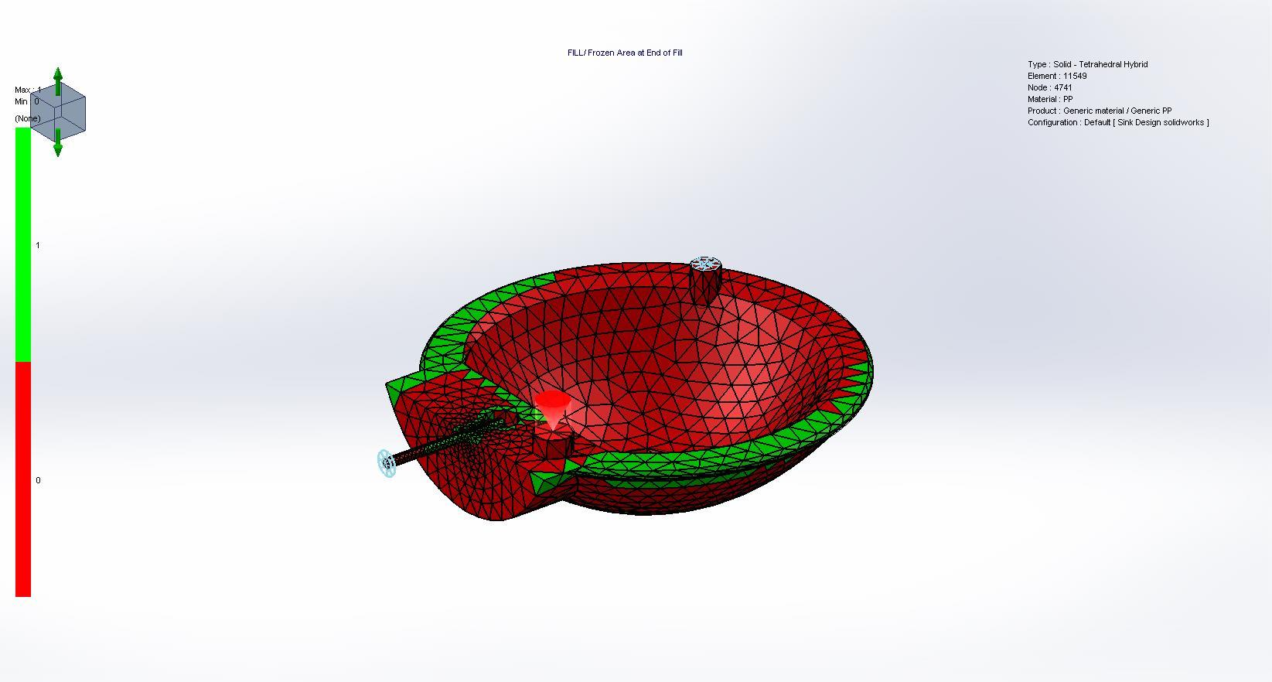

Name | Type | Min | Max
Velocity Vector at End of Fill | Fill Results | 0.000022 | 100.619127
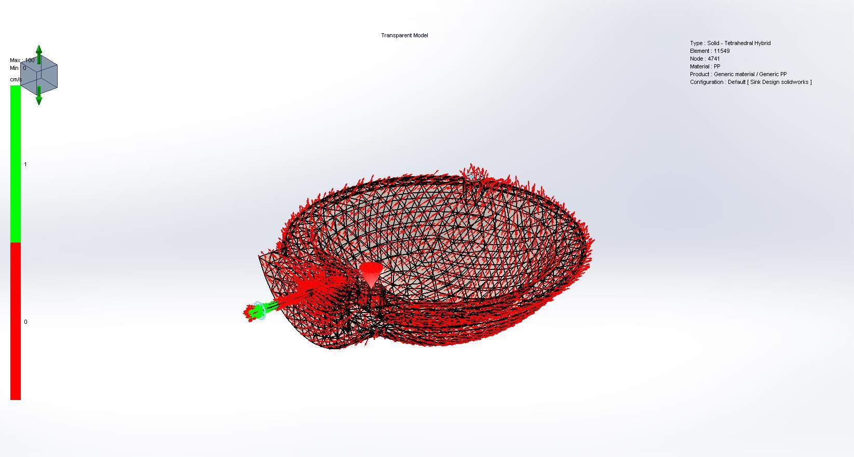

Name | Type | Min | Max
Gate Filling Contribution | Fill Results | 0.000000 | 1.000000
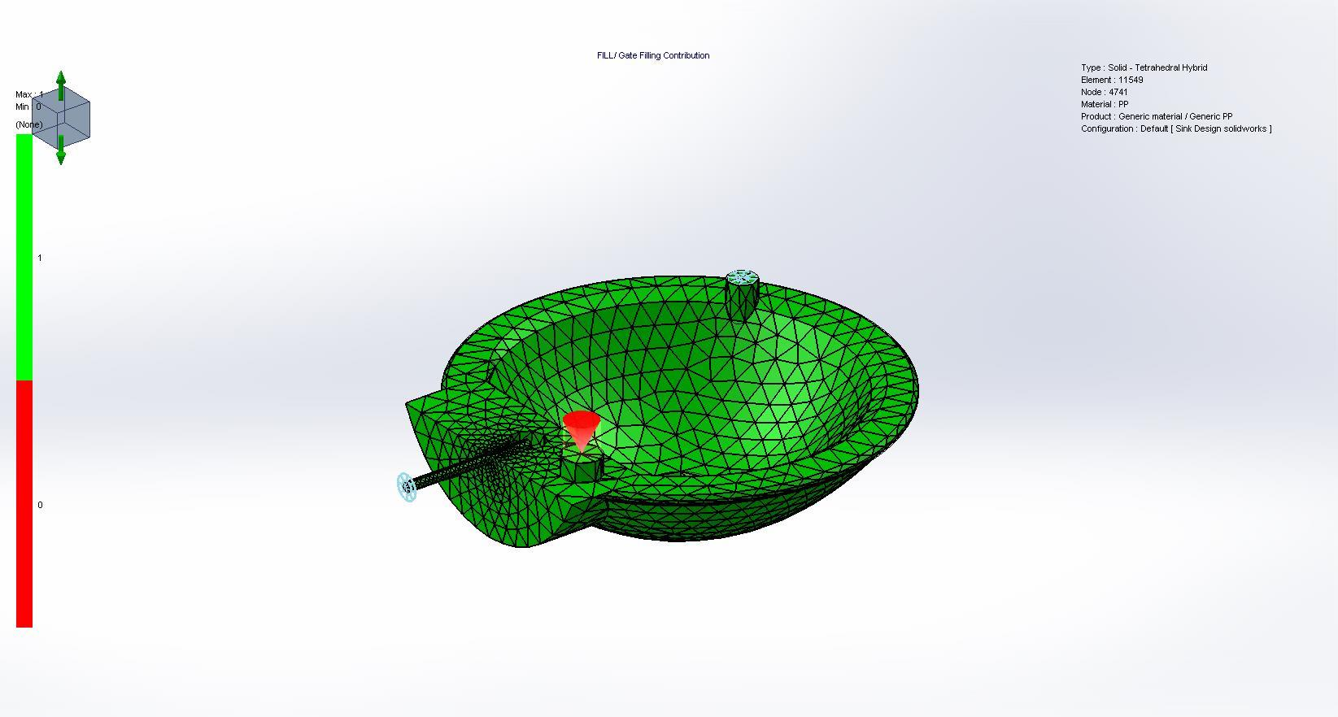

Name | Type | Min | Max
Ease of Fill | Fill Results | 0.000000 | 2.000000
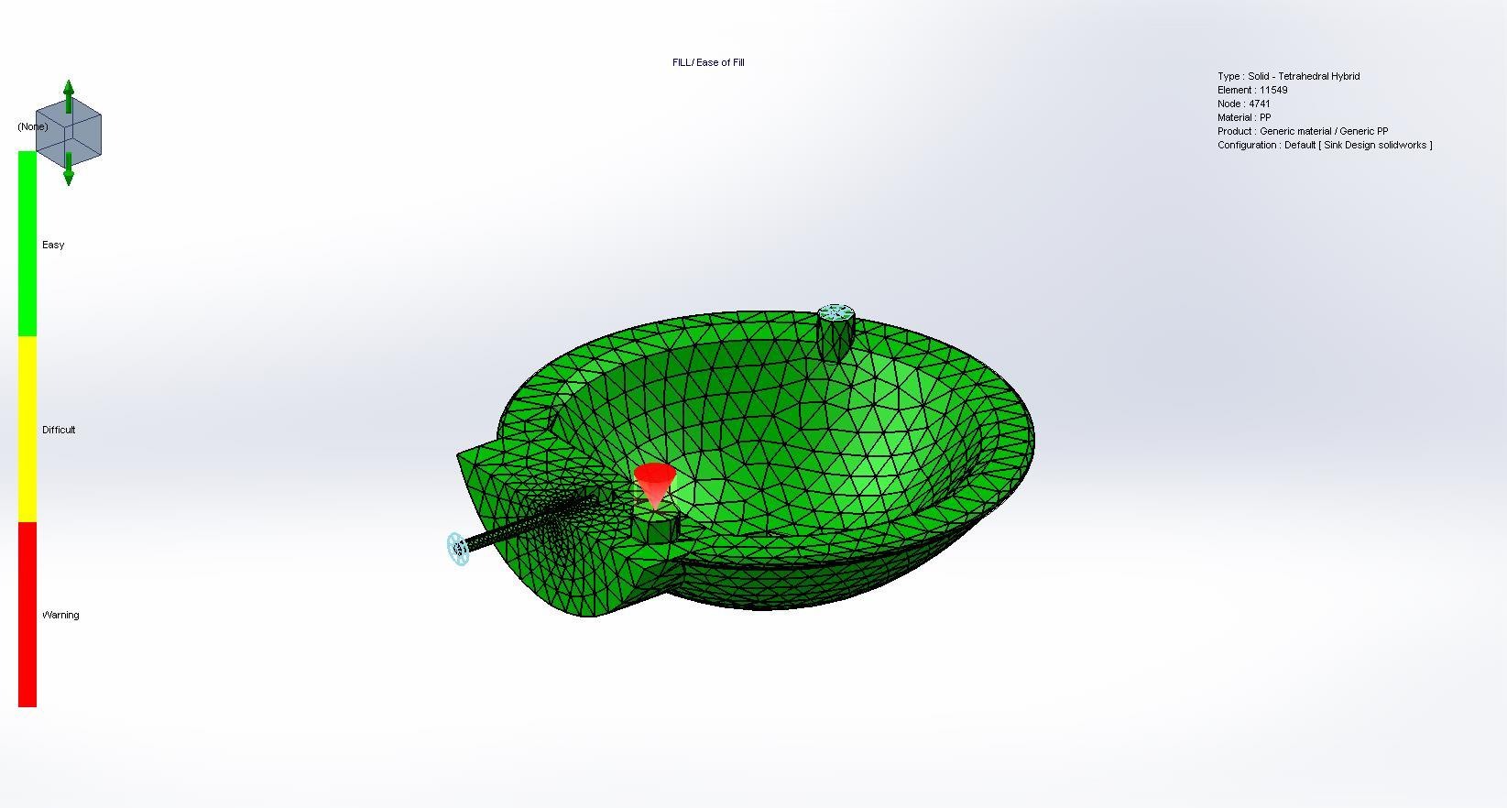

Name | Type | Min | Max
Weld Lines | Fill Results | 3.490000 | 147.910004
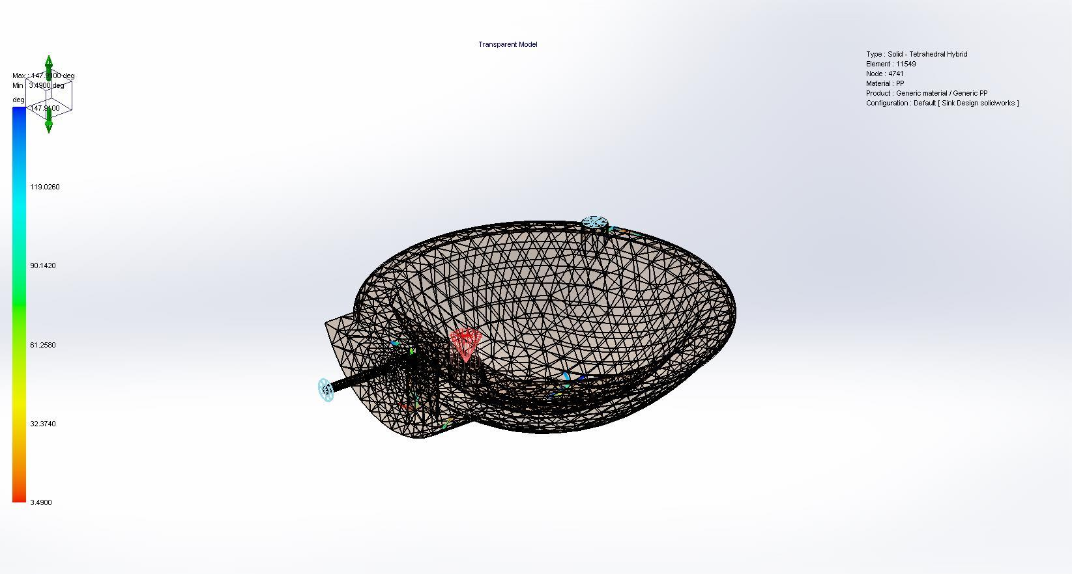

Name | Type | Min | Max
Air Traps | Fill Results | 0.010087 | 10.155290
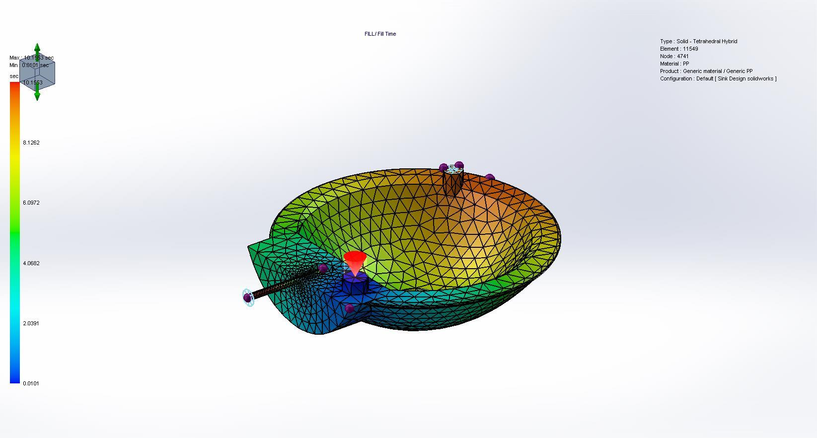

Pack Results
Comments:

Pack Summary
Clamp Force | 29.5291 Tonne
X-dir. Clamping Force | 14.3119 Tonne
Y-dir. Clamping Force | 29.5291 Tonne
Z-dir. Clamping Force | 14.7500 Tonne
Max. real temperature | 229.3655 °C
Max. bulk temperature | 230.0257 °C
Max. shear stress | 0.3484 Mpa
Max. shear rate | 0.3235 1/sec
Max. residual stress | 59.1820 Mpa
Mass at the end of packing | 502.88 (g)

Name | Type | Min | Max
Pressure at End of Packing | Pack Results | 0.100000 | 3.404000
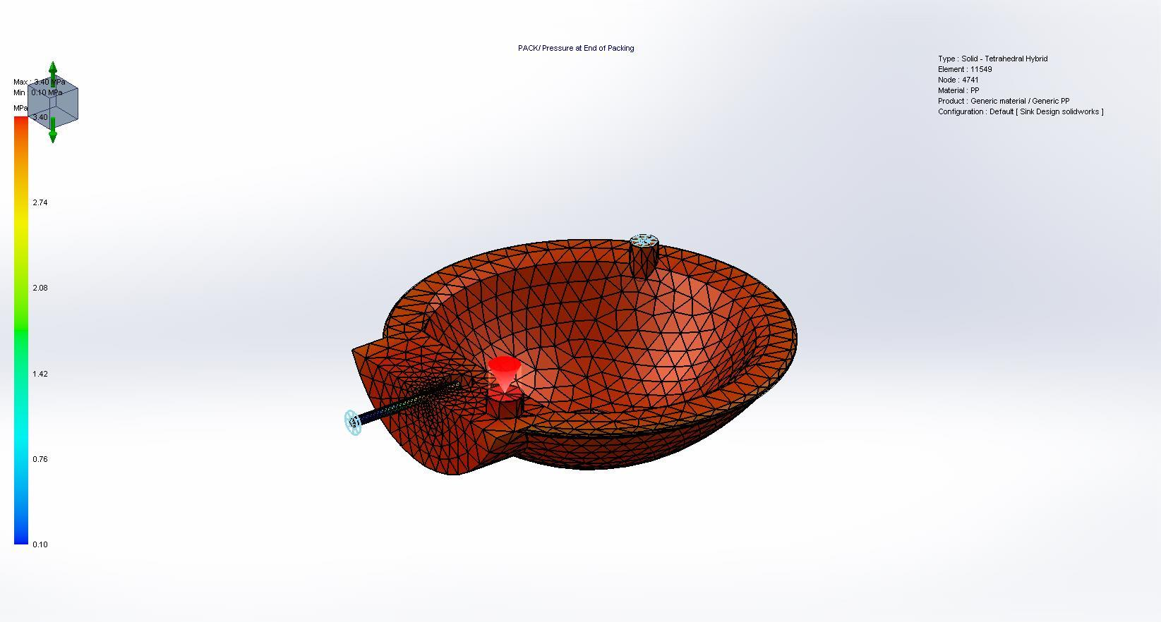

Name | Type | Min | Max
Temperature at End of Packing | Pack Results | 54.794930 | 229.835205
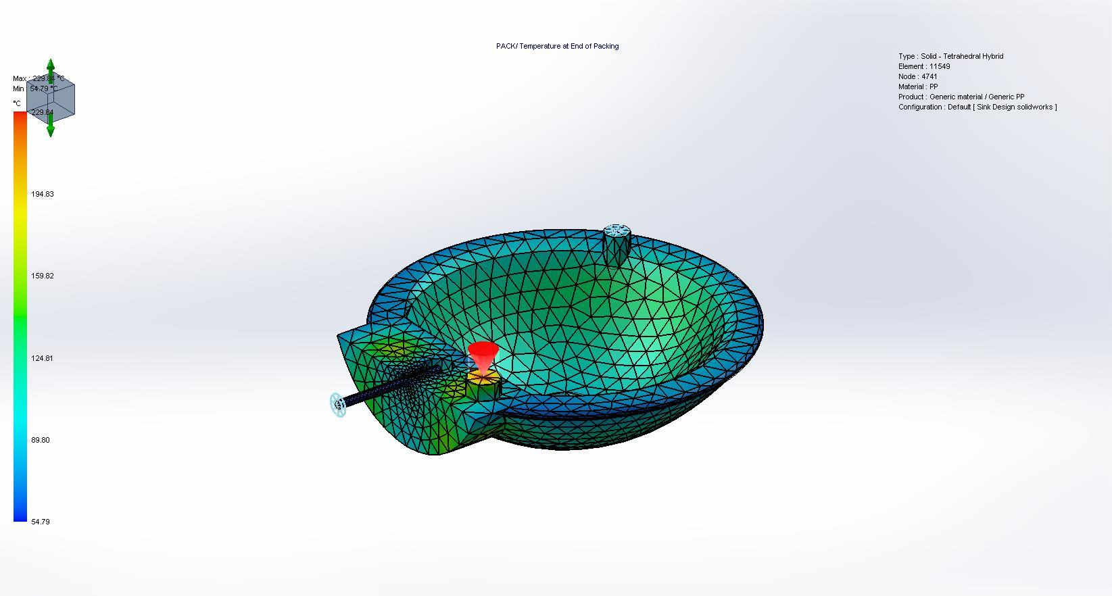

Name | Type | Min | Max
Bulk Temperature at End of Packing | Pack Results | 55.030510 | 229.875702
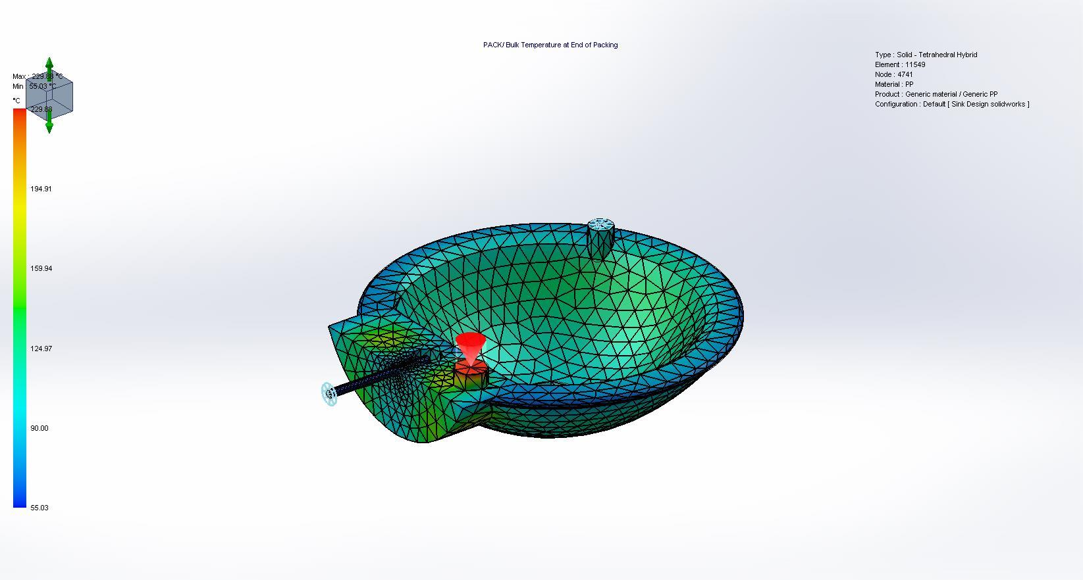

Name | Type | Min | Max
Density at End of Packing | Pack Results | 0.787553 | 0.945057
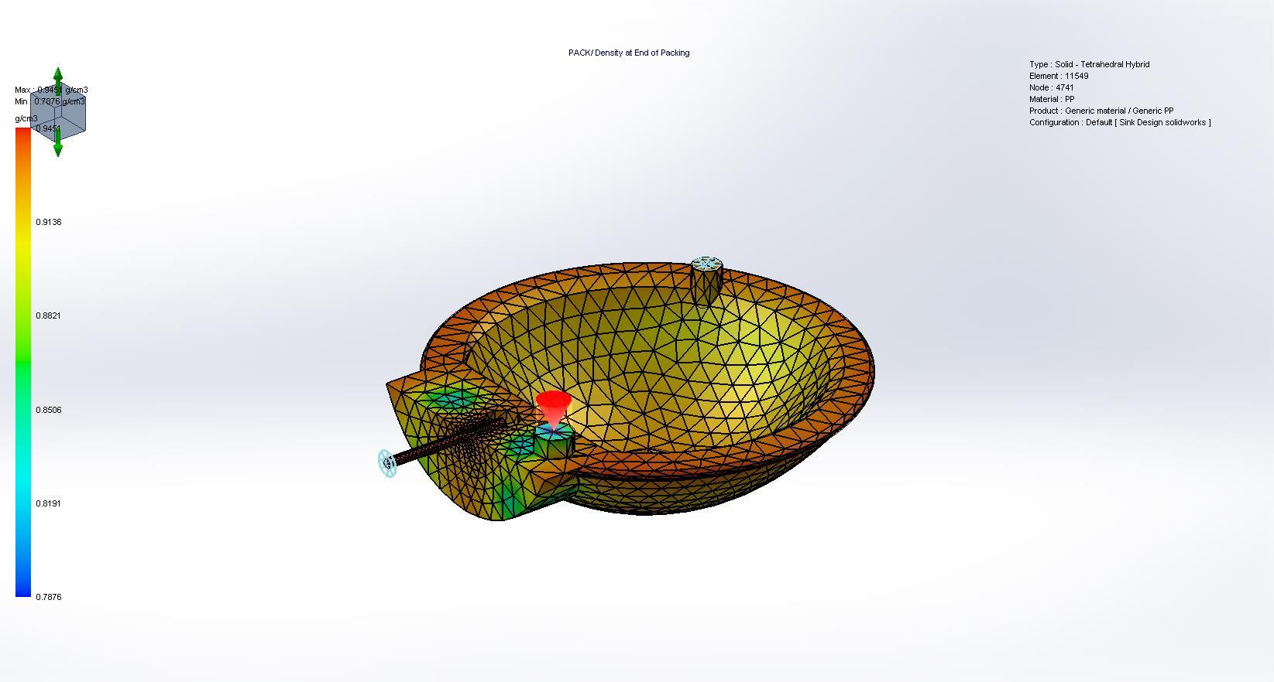

Name | Type | Min | Max
Shear Stress at End of Packing | Pack Results | 0.000087 | 0.348427
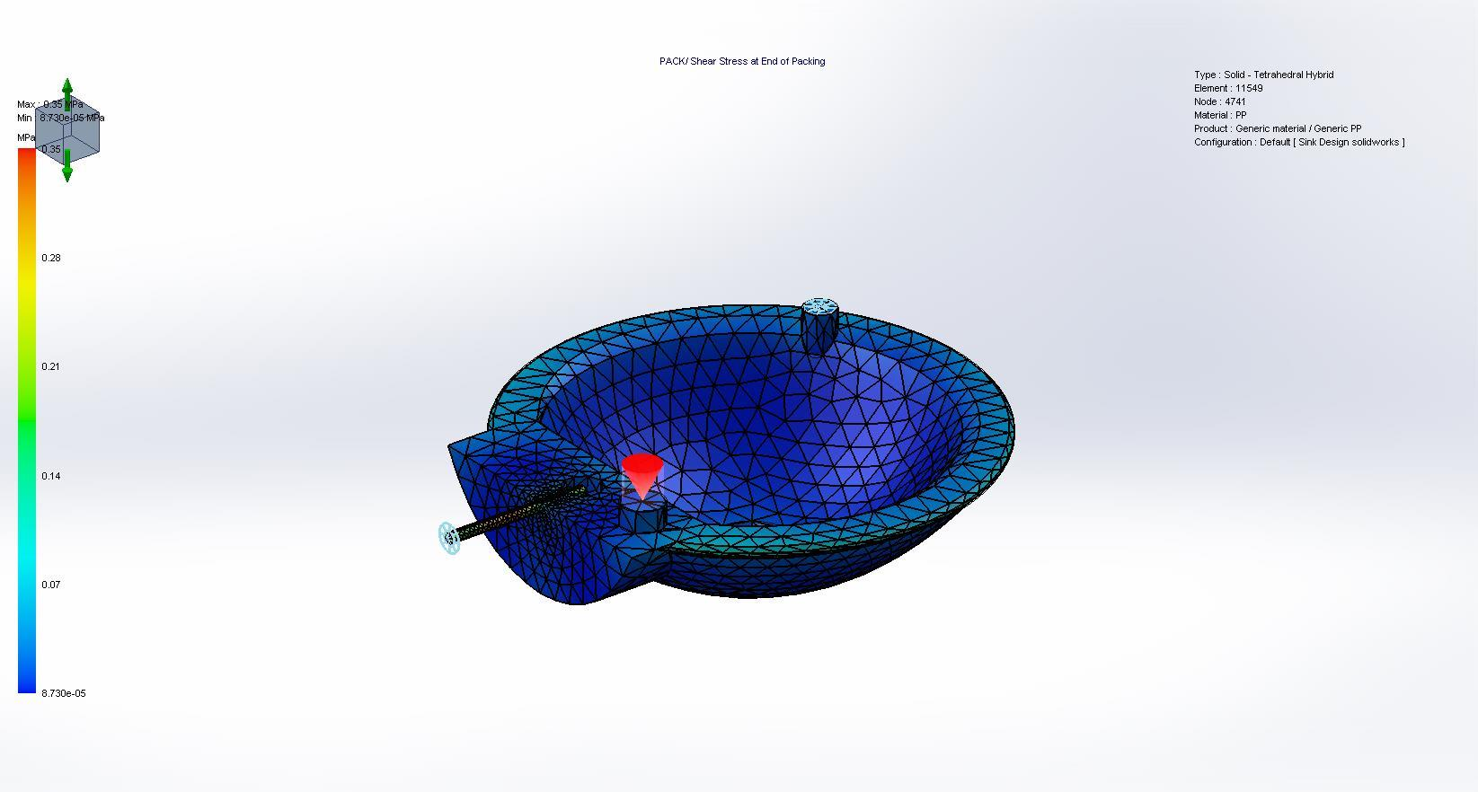

Name | Type | Min | Max
Shear Rate at End of Packing | Pack Results | 0.000157 | 0.323529
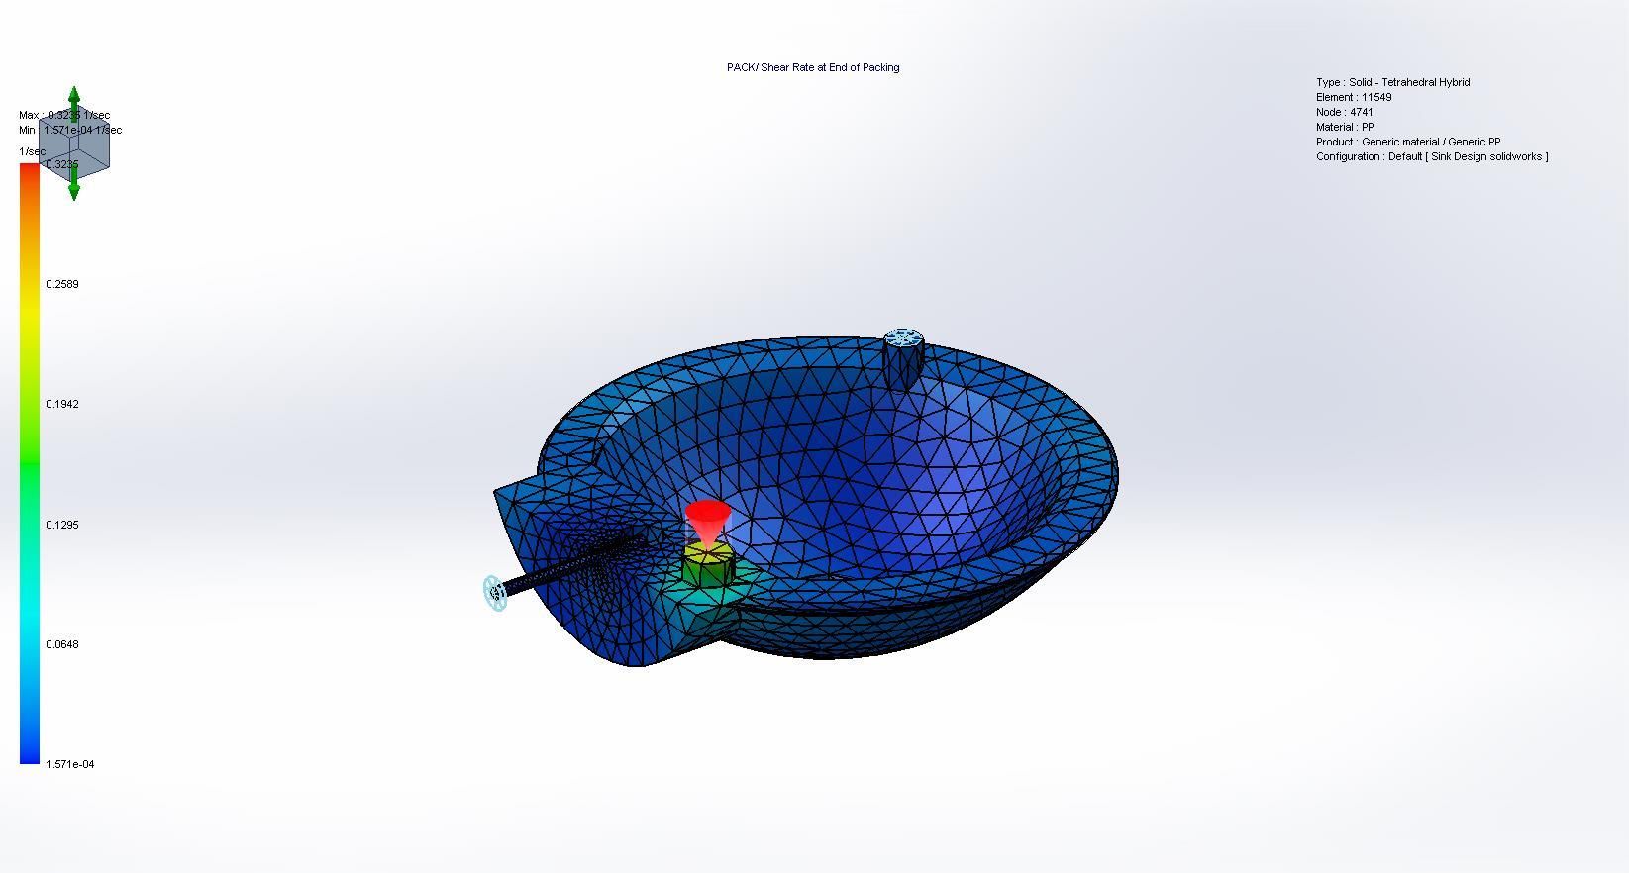

Name | Type | Min | Max
Volumetric Shrinkage at End of Packing | Pack Results | 2.017585 | 17.734529
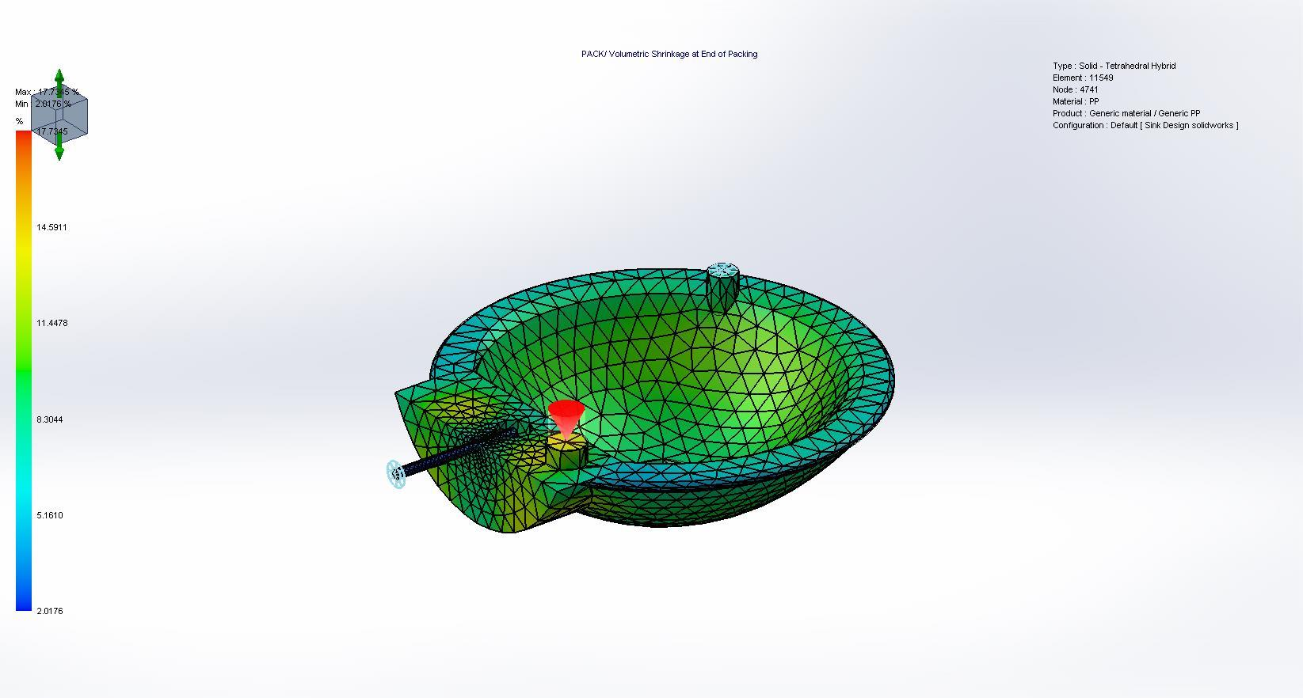

Name | Type | Min | Max
Temperature at Post-Filling End | Pack Results | 50.119011 | 229.215500
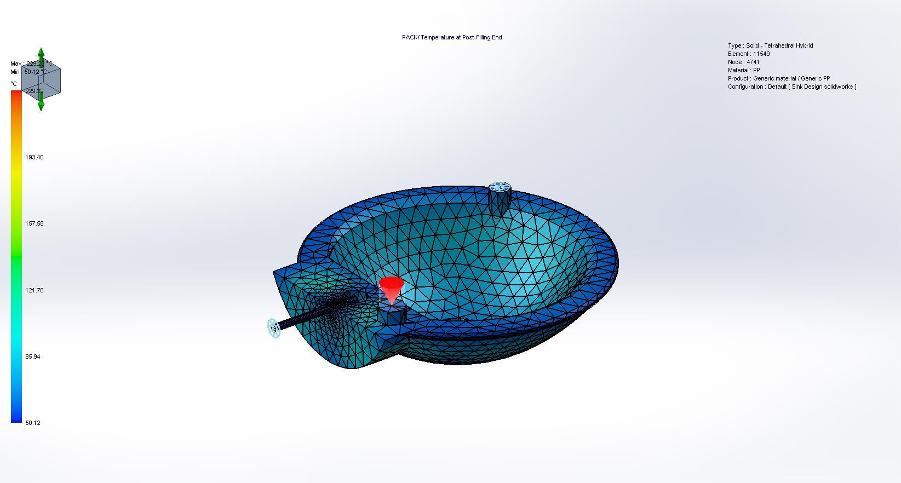

Name | Type | Min | Max
Freezing Time at Post-Filling End | Pack Results | 1.953608 | 107.925301
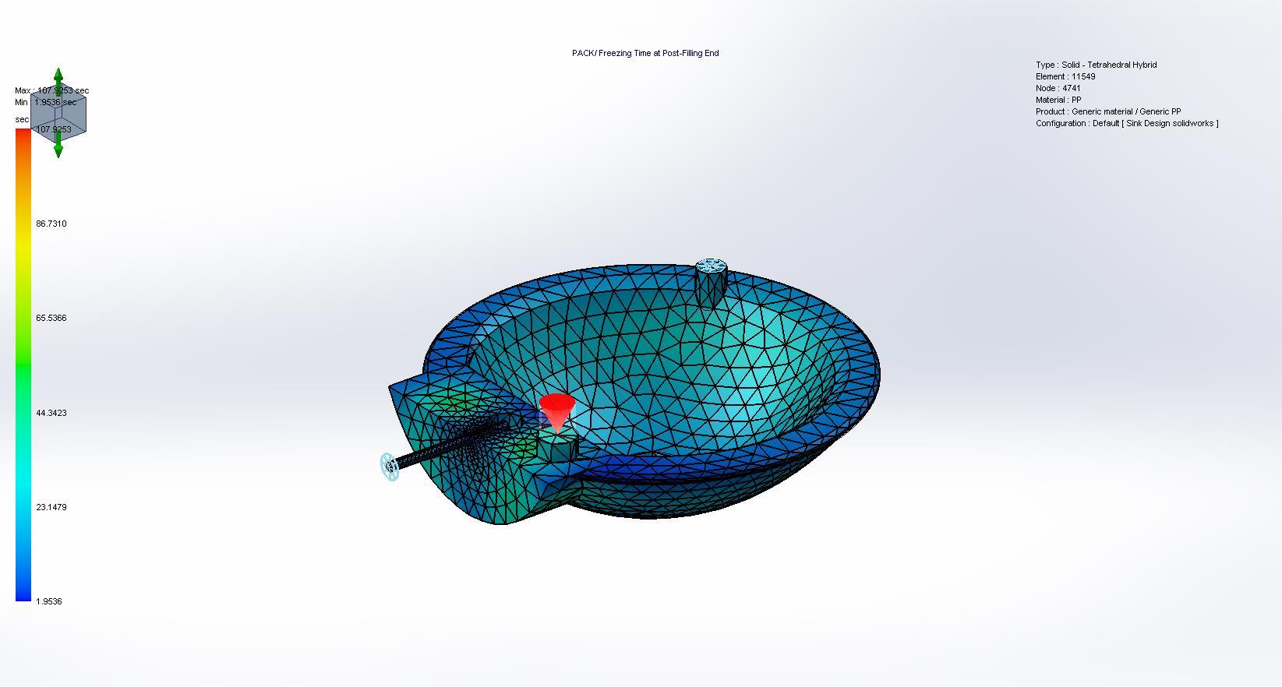

Name | Type | Min | Max
Residual Stress at Post-Filling End | Pack Results | 4.123033 | 59.182018
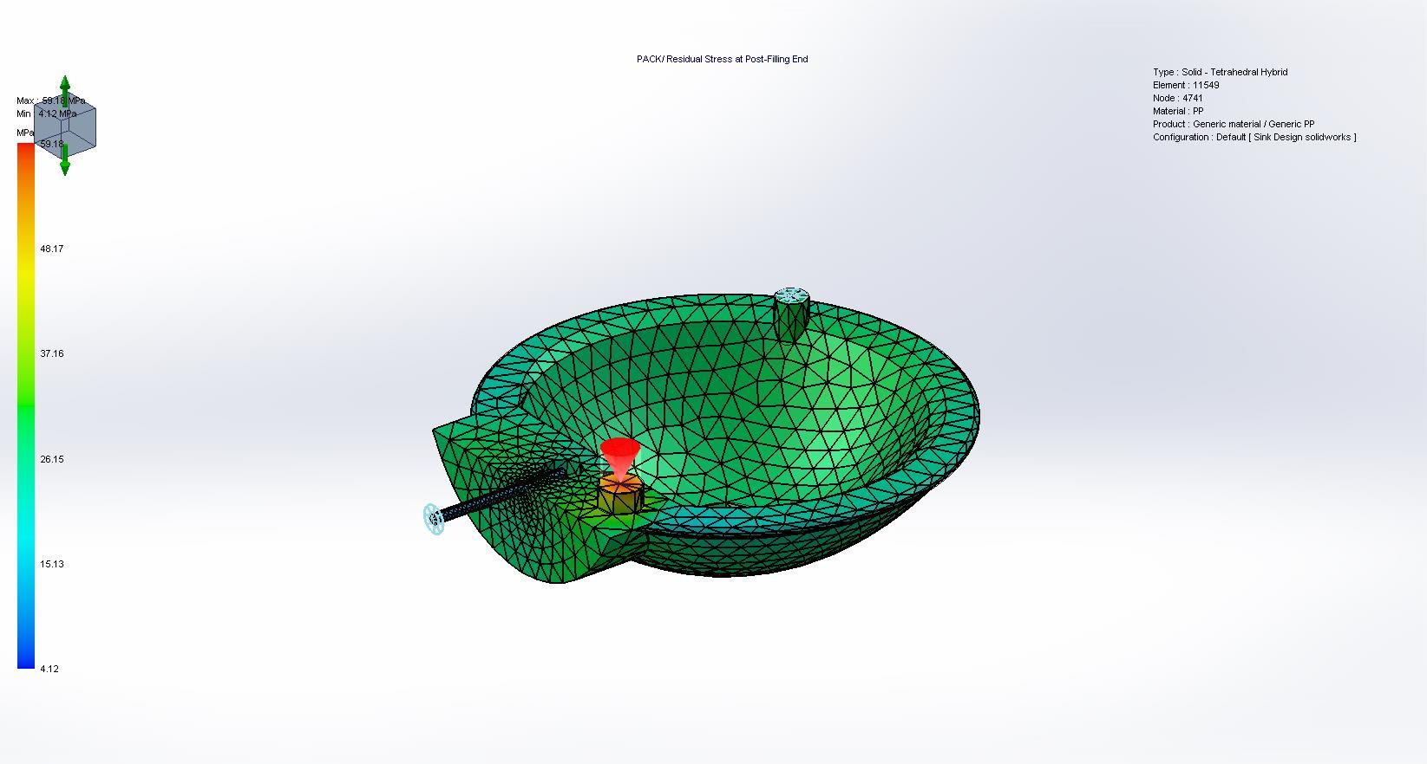

Name | Type | Min | Max
Sink Marks at Ejection | Pack Results | 0.000000 | 1.118917
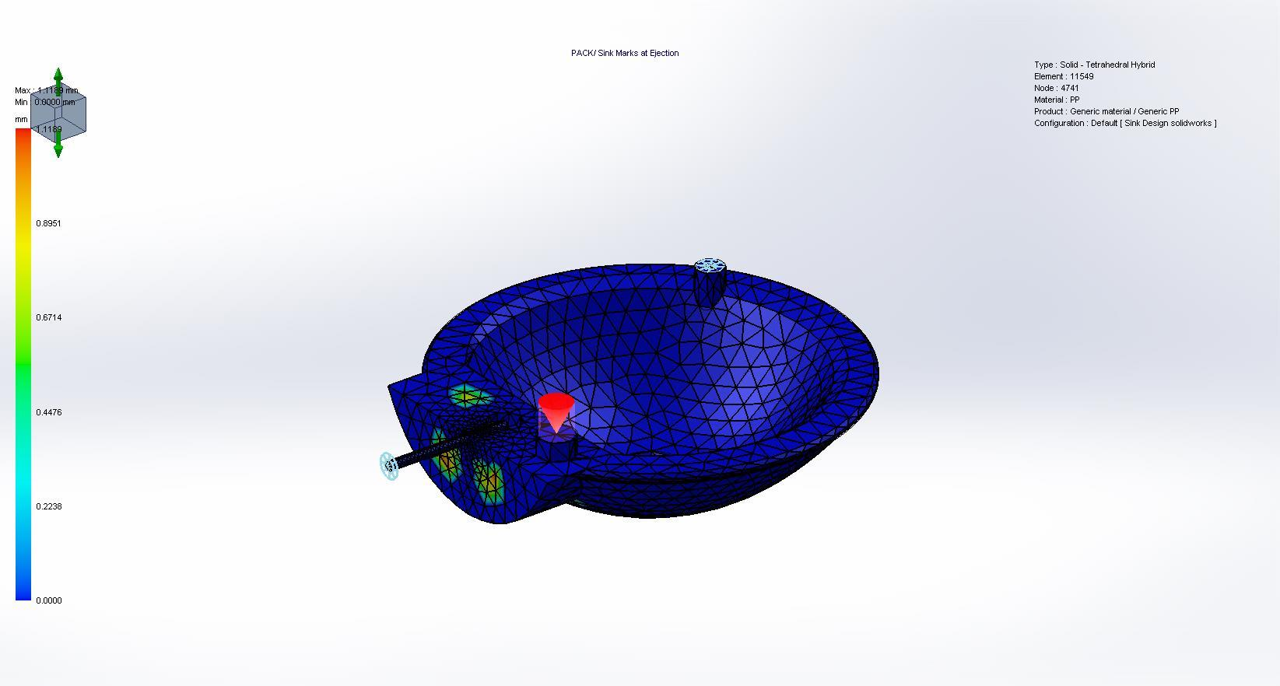

Name | Type | Min | Max
Frozen Area at Post-Filling End | Pack Results | 0.000000 | 1.000000
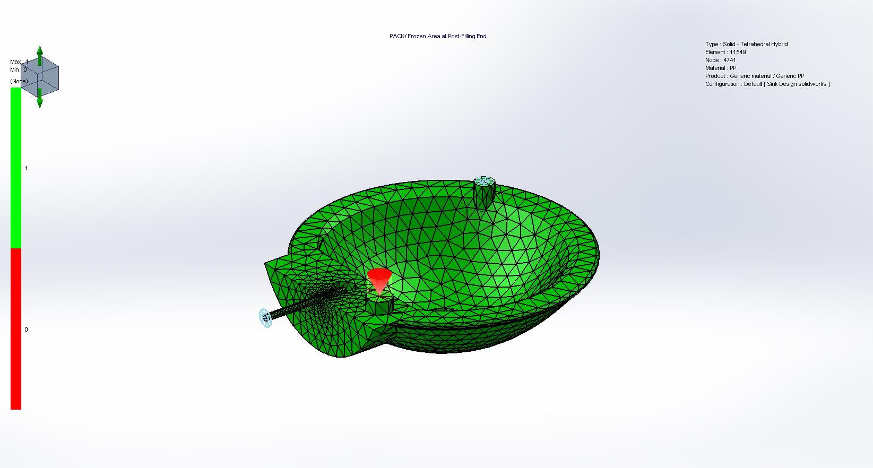

Material Parameter
Comments:
Name | Type | Min | Max
Polymer Viscosity Graph | Material Parameter
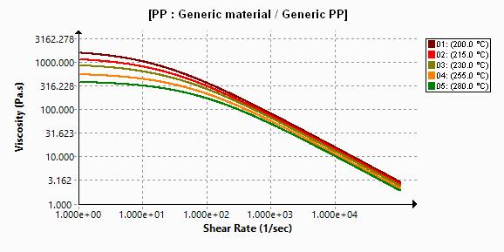

Name | Type | Min | Max
Polymer Specific-Volume Graph | Material Parameter
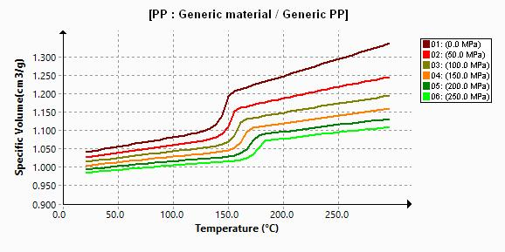

Name | Type | Min | Max
Polymer Specific-Heat Graph | Material Parameter
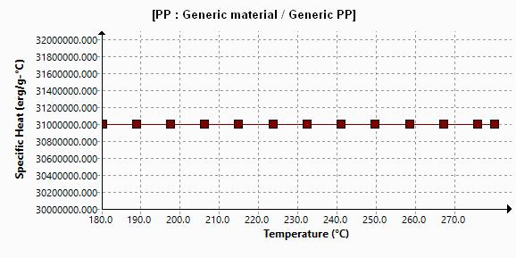

Name | Type | Min | Max
Polymer Thermal-Conductivity Graph | Material Parameter
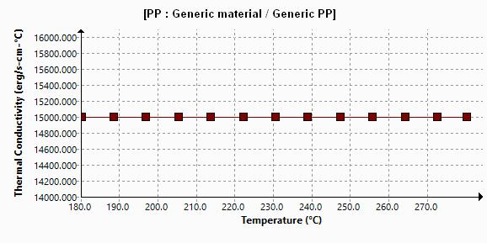

Name | Type | Min | Max
Polymer Elastic-Modulus Graph | Material Parameter
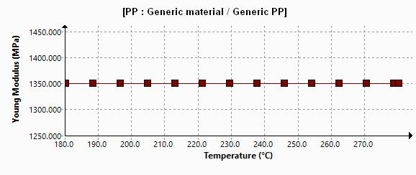

Name | Type | Min | Max
Polymer Poisson-Ratio Graph | Material Parameter
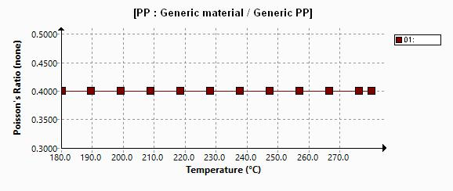

Name | Type | Min | Max
Polymer Linear-Thermal-Expansion-Coefficient Graph | Material Parameter
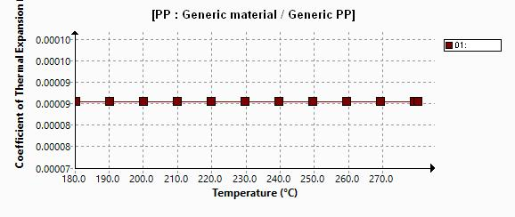

Name | Type | Min | Max
Polymer Relaxation-Modulus Graph | Material Parameter
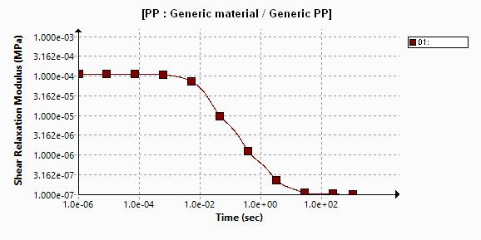

X-Y Plot
Comments:
Name | Type | Min | Max
Max. Injection Pressure | X-Y Plot | 0.000000 | 8.266000
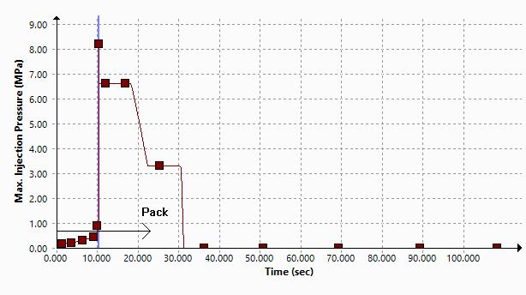

Name | Type | Min | Max
Melt Front Flow Rate | X-Y Plot | -65.820000 | 65.669998
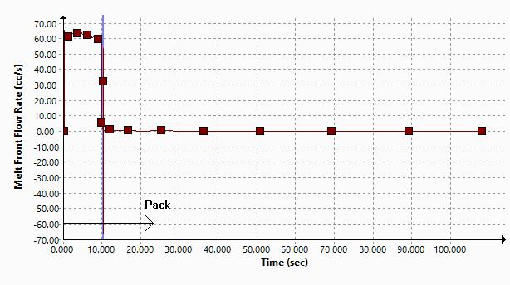

Name | Type | Min | Max
Clamp Force | X-Y Plot | 0.000000 | 29.528999
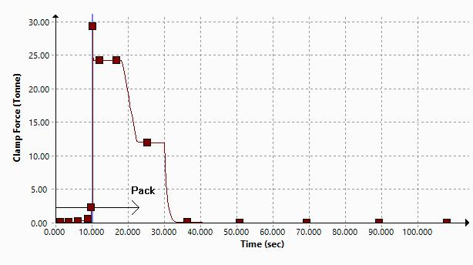

Name | Type | Min | Max
Part Mass | X-Y Plot | 0.000000 | 502.882996
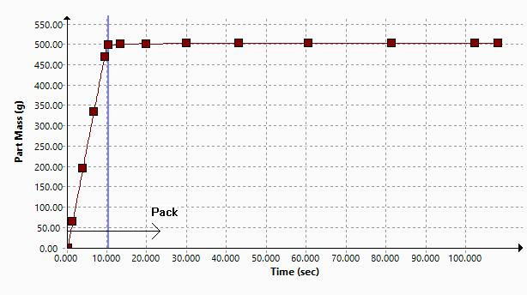

Conclusion:

